**Provider Data Management – Use case Document for Common Data Scenarios.**

**Problem definition:-**

Each payers in US maintains healthcare provider data (individual physicians, hospitals) based on their process needs. It’s stored in different forms of databases such as IMS, DB2, and Cloud and are very huge in no of records. Those are actually redundant and very complex to standardize, manage and maintain. The provider data is being handled/maintained by a group of folks called PDMs (Provider Demographic Managers) who will add, update and remove data attributes.

The proposed solution is to handle commonly shared provider attributes such as demographic information (profile, address etc), specialty codes, and sanctions etc. using blockchain technology. The providers (physicians/hospitals) will be the source of truth for their own data instead of depending on PDMs to have regular updates. The changes made from provider will be shared across different payers for their validations and claims processing.

**Current State:**

* Individual PDMs will update provider data for all healthcare payers such as Anthem, Aetna, and United Healthcare etc.
* Each payers keep redundant data in their respective provider systems for same providers.
* Different database models being used to update provider data (IMS, DB2, Cloud, Unix etc).
* Thousands of PDM associates (Offshore, Nearshore and Onshore) are working on to correct/update provider data based on different needs.
* Data updates will take time and regular delays in claims processing and claims denial processes and then provider finder applications (provider portal, consumer portal etc).

**Proposed State:**

* Centralized provider Data management system using BlockChain.
* The same provider system will be used across different payers for their provider validations.
* Provider/Doctors office or Hospital will update their own details.
* Should have a new capability to pull reports of demographic and reimbursement details for any government or federal Audits.
* It should handle all below PDM needs.

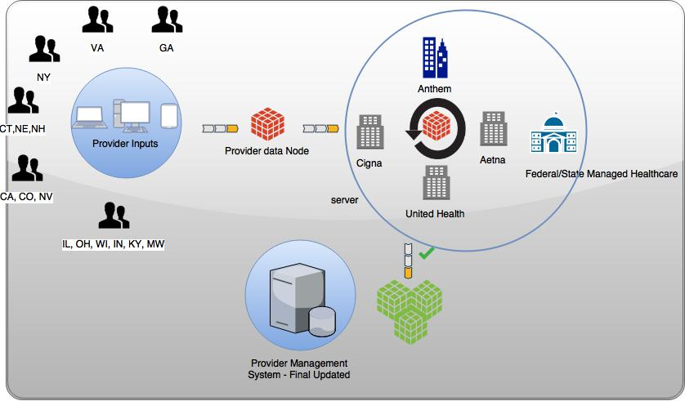

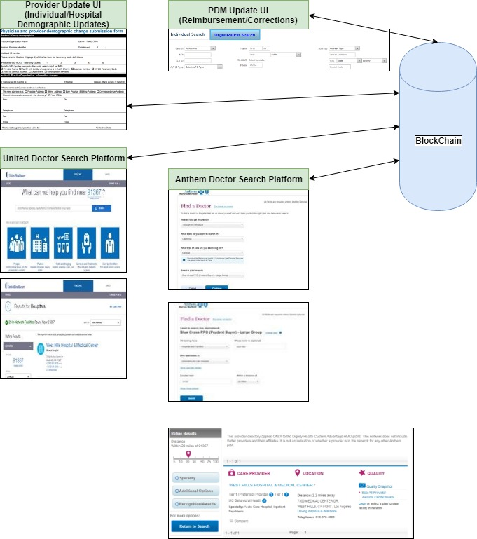

**Provider Data Scenarios**

|  |  |  |  |  |
| --- | --- | --- | --- | --- |
| **Use Case ID** | **Description** | **Type** | **Priority** | **Remarks** |
| 1 | Provider Enrollments  1. Add/Enroll new providers under hospital.  2. Terminate an existing provider. | Demographic | 1 | Adding new provider, changing effective dates, terminating a provider. |
| 2 | Address changes | Demographic | 1 | Change in Address line1, City, State, County, Country, address types, |
| 3 | Add/Terminate specialties, board certification. | Demographic | 1 | Adding new specialties, changing effective dates and adding board certification statuses. |
| 4 | Add sanction details | Demographic | 1 | Adding different sanction codes to handle providers. |
| 5 | Add/Terminate Contracts and Networks. | Reimbursement | 1 | Add different contracts and networks for reimbursement. |
| 6 | Send details to DMHC/Lexis Nexis or government organizations for audits/TAR reports. | Reporting | 2 | Reports for the required providers. |
| 7 | Search individual and hospital providers. | General | 1 | Provider search options. |

**Sample Provider Screens.**

**PDM Update UI:**

**For Individual Providers/Physicians – Search Screen.** (Should have a log in UI with user name and password).

Individual Search.



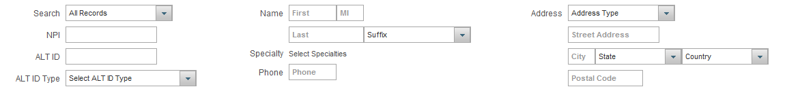

* Inpout the details in search page.
* Can add a radio button in the page for Update for new providers.
* Minimum is NPI, Last Name search and then filters on First name.

Hospital Search.



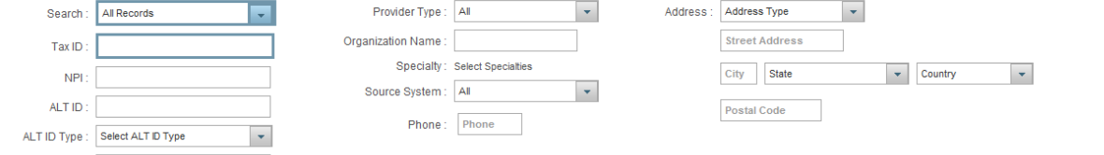

* Input the details in search page.
* Can add a radio button in the page for Update for new providers.
* Minimum isTax ID, NPI, Business Name search and then filters on state, City.



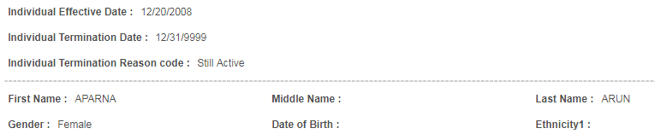

* Enable an Update Radio button on above screen for Update.
* Special access required for update.
* Ethnicity is available in current screens, but can avoid in the prototype.

**Alternate ID screen:**

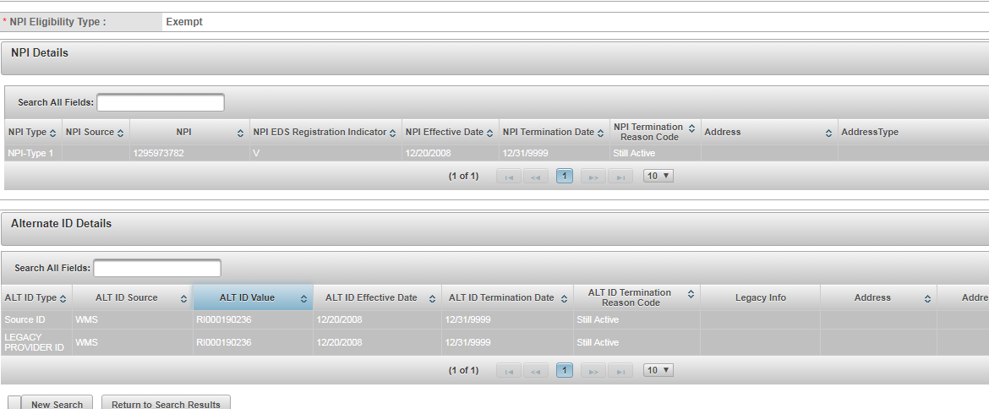

* Enable an Update Radio button on above screen for Update.
* Special access required for update.
* Included only major alternate IDs. Minimum info required is NPI.

**Specialty and Board certification details.**

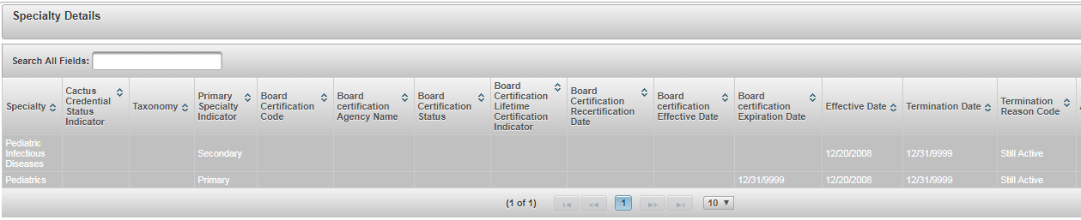

* Enable an Update Radio button on above screen for Update.
* Special access required for update.
* We do not require Cactus credential field in demo. Second column can be removed.
* Minimum info required is specialty, effective, end dates and reason codes.

**Address Screen**

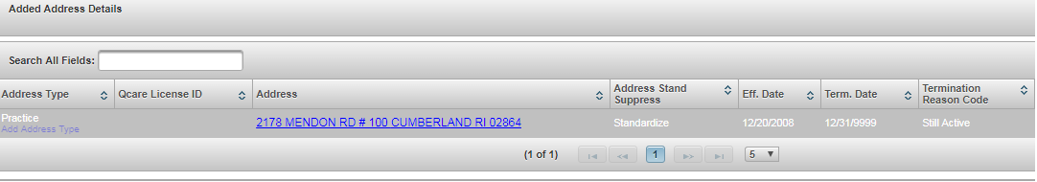

* Enable an Update Radio button on above screen for Update.
* Special access required for update.
* We do not require Qcare License ID field in demo. Second and Third columns can be removed.
* Minimum info required is address, effective, end dates and reason codes.
* Please add separate lines for Address line1, Address Line 2, City, State, Zip, County and County.

**Sanction Screen**

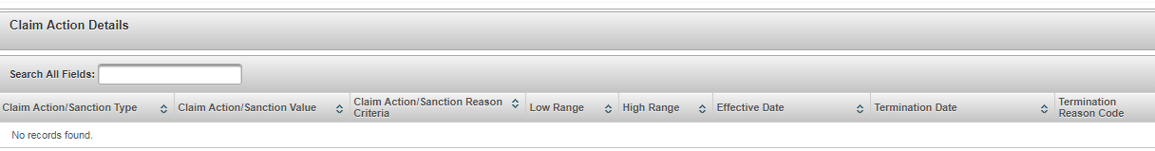

* Enable an Update Radio button on above screen for Update.
* Special access required for update.
* We just need claims action/sanction type (column1), value (column2), effective, end and term reason code columns.

**Provider Update UI:**

Updated in the attached Excel.



**Sample Provider Update form for provider Update UI.**





**CFF Data Copybook**



**Sample Provider data**



**Organization/Hospital Provider:**

TAXID: 952624909

Provider Name: West Hills Hospital and Medical center.

Facility ID/Medicare ID - 050481

Billing NPIs - 1023065729/1801833900

Practice Address:

ADDR1: 7300 MEDICAL CENTER DR

CITY: WEST HILLS

State: CA

ZIP: 91307 1902

COUNTY: 037

CNTRY: USA

Billing Address:

CHK NAME: WEST HILLS HOSPITAL & MEDICAL CENTER

ADDR1: PO BOX 409434

CITY: ATLANTA

State: GA

ZIP: 30384 9434

COUNTY: 121

CNTRY: USA

Hospital Specialties:

WGS LEGACY TAXONOMY   DESCRIPTION         PR BC

01  222    281PC2000X HOSPITAL, ACUTE CAR Y

15  1957   273R00000X BEHAVIORAL HEALTH - N

**Individual Provider:**

SID: 0001904528

PCP: W57169

LNAME: SCHALL

FNAME: PERRY

MI: M

GNDR: M

NPI: 1497779219

WGS LEGACY TAXONOMY   DESCRIPTION         PR BC

275 10244  207R00000X INTERNAL MEDICINE   Y  N

Practice Address:

ADDR1: 23388 MULHOLLAND DR

CITY: WOODLAND HILLS

State: CA

ZIP: 91364 2733

COUNTY: 037

CNTRY: USA

**Glossary:**

**Specialties:**

Physician specialties (e.g 275 – Internal Medicine)

**Sanction:**

Any individual or organization which is excluded from federal healthcare programs is said to have been “sanctioned”. Sanctioned individuals and entities are barred from participating in federal healthcare programs such as Medicare and Medicaid. The Department of Health and Human Services (HHS) Office of Inspector General (OIG) has the authority to exclude individuals and entities from federally funded health care programs and maintains the List of Excluded Individuals and Entities —a list of all excluded individuals and entities, also known as sanctioned medical providers (SMP).

Sample Sanction Codes:-

|  |  |
| --- | --- |
| Type | Details |
| 8006 | LICENSE SUSPENDED |
| 8011 | PROVIDER ON AUDIT |
| 8012 | SANCTIONED PROVIDER |
| 8028 | BANNED |
| 8080 | CAF/Fraud |

**DMHC/TAR Reports:**

These are critical audit reports being requested every year from department of health, Covered CA etc.